SIMATS ENGINEERING
Assignment
COURSE NAME: OBJECT ORIENTED ANALYSIS AND DESIGN
COURSE CODE: CSA1107

COURSE OUTCOME COVERED
CO1: Analyse the fundamentals of Object-Oriented Systems Development, including object basics, Object-Oriented Systems Development Life Cycle, Object-Oriented Methodologies, Model-Driven Development (MDD), and Agile practices.
CO2: Apply UML techniques including Use Case, Class, Interaction, State Transition, Activity, Package, Component, and Deployment Diagrams to model a software system.
CO3: Analyse objects, classes, attributes, methods, and relationships through Use Case Modelling, Object Analysis, Classification, and identification of object relationships.

Assignment Weightage: 100%

QUESTIONS: 1 Total Marks:100
Annexure A
Assignment

Code of Conduct:

I Sanjana.G(192511020) (Name / Reg No) certify that this submission is my original work and that I have adhered to the guidelines specified for this assessment.
I understand that any violation of academic integrity rules will result in disciplinary action.
Sanjana.G
Signature of the student:

Course Code & Name
CSA1107 – Object Oriented Analysis and Design
Assignment Title | Object-Oriented Analysis and UML-Based Design of an Intelligent Food Waste Reduction and Redistribution System (IFWRRS)
Course Outcome(s) – CO | CO1: Analyse Object-Oriented Systems Development concepts and methodologies to understand and model a real-world software problem.  CO2: Apply UML modelling techniques including Use Case, Class, Interaction, State Transition, Activity, Package, Component, and Deployment Diagrams.  CO3: Analyse objects, classes, attributes, methods, and relationships through Use Case Modelling, Object Analysis, Classification, and relationship identification.
Bloom’s Taxonomy Level | BL3 – Apply, BL4 – Analyse, BL5 – Evaluate, BL6 – Create
SDG Mapping (SDG 1–17) | SDG 2 – Zero Hunger  SDG 11 – Sustainable Cities and Communities  SDG 12 – Responsible Consumption and Production  SDG 13 – Climate Action

Problem Statement
Analyse and develop an Object-Oriented Analysis and Design model for an Intelligent Food Waste Reduction and Redistribution System (IFWRRS) that connects restaurants, hotels, supermarkets, food suppliers, charitable organizations, delivery partners, and administrators to reduce avoidable food waste and facilitate timely redistribution of surplus food.
The system shall allow registered food providers to record surplus food, specify quantity, type, preparation time, expiry period, storage requirements, and pickup location. The system shall identify suitable recipient organizations based on food requirements, location, quantity, urgency, and availability.
Recipient organizations shall be able to view available food donations, request suitable items, confirm collection, and update distribution status. Delivery partners shall receive pickup and delivery assignments and update the transportation status. Administrators shall monitor food donations, organizations, deliveries, users, and system reports.
The system shall generate notifications when surplus food is approaching its expiry period and support intelligent matching between food providers and recipient organizations. Working from this scenario, students shall identify actors, objects, classes, attributes, methods, and relationships and develop Use Case, Class, Sequence, Activity, State Transition, Package, Component, and Deployment Diagrams.
Students shall analyse object responsibilities and apply suitable design principles and design patterns to achieve high cohesion, low coupling, reusability, maintainability, and scalability.

Constraints
The design shall clearly distinguish different stakeholders and their responsibilities. All identified classes, attributes, operations, and relationships shall be traceable to the identified use cases.
The system shall consider food expiry, notification timing, matching criteria, delivery status, user roles, data consistency, and transaction management. UML diagrams shall be mutually consistent and shall accurately represent the proposed system behaviour.
The final submission shall include assumptions, constraints, object responsibility analysis, design-pattern justification, and traceability between requirements, use cases, and design elements.

Tools Can Be Used
- StarUML
- Visual Paradigm
- Draw.io
- PlantUML
- Papyrus Tools
- ArgoUML
- Enterprise Architect
- Lucidchart

Assessment Rubrics
Criteria (CO Mapping) | Max Marks | Excellent | Good | Satisfactory | Needs Improvement
Problem Understanding, Object Identification & Requirements Analysis (CO1) | 10 | Clearly analyses the problem domain and accurately identifies all major actors, objects, system responsibilities, and requirements from the given scenario. | Identifies most actors, objects, and requirements with minor gaps or inaccuracies. | Identifies basic actors and objects but analysis is incomplete or contains some inconsistencies. | Poor understanding of the problem; major actors, objects, and requirements are missing or incorrectly identified.
Use Case Modelling & Actor Identification (CO2) | 10 | Correctly identifies all relevant actors and use cases; Use Case Diagram clearly represents system boundary, relationships, and interactions. | Most actors and use cases are correctly identified with minor modelling errors. | Basic actors and use cases are identified, but relationships or system boundary need improvement. | Actors and use cases are poorly identified; diagram is incomplete or inconsistent.
Class Identification, Attributes, Methods & Relationships (CO2/CO3) | 15 | Classes, attributes, methods, associations, aggregation/composition, inheritance, and dependencies are accurately identified and logically justified. | Class structure is mostly correct with minor errors in attributes, methods, or relationships. | Basic classes and relationships are identified but lack detail or contain several modelling issues. | Classes, attributes, methods, or relationships are missing, inappropriate, or poorly structured.
UML Behavioural & Interaction Modelling (CO2) | 15 | Sequence, Activity, and State Transition Diagrams accurately represent system behaviour and are fully consistent with the identified use cases and classes. | Behavioural diagrams are mostly correct with minor inconsistencies. | Basic behavioural diagrams are provided but some interactions, activities, or states are incomplete. | Behavioural diagrams are missing, unclear, or inconsistent with the proposed system.
UML Architectural Modelling & Design Evaluation (CO3) | 15 | Package, Component, and Deployment Diagrams clearly represent modular structure, system components, dependencies, and deployment environment with strong justification. | Architectural diagrams are mostly correct with minor omissions or modelling errors. | Basic architectural representation is provided but lacks clarity or sufficient justification. | Architectural diagrams are incomplete, inappropriate, or inconsistent with the system design.
Object Responsibilities, Design Principles, Axioms & Patterns (CO3) | 15 | Responsibilities are appropriately assigned; design axioms, cohesion, coupling, encapsulation, abstraction, and suitable design patterns are clearly justified and effectively applied. | Design principles and patterns are appropriately applied with minor limitations in justification. | Some design principles are identified, but application or justification is limited. | Design principles, axioms, responsibilities, or patterns are absent or incorrectly applied.
Consistency, Traceability & Overall Design Quality (CO3) | 10 | All UML models are mutually consistent, requirements are traceable to use cases/classes, and the overall design is complete, feasible, scalable, and maintainable. | Design is largely consistent and traceable with minor gaps. | Some consistency and traceability are demonstrated, but important links are missing. | Major inconsistencies exist between requirements, use cases, classes, and UML diagrams.
Reflection, SDG Relevance & Learning Outcomes | 10 | Provides insightful reflection on design decisions, challenges, OOAD concepts learned, and clearly establishes the relevance of the selected SDGs. | Provides good reflection with reasonable connection to design decisions and SDGs. | Reflection is present but generic with limited discussion of learning and SDG relevance. | Reflection is missing, superficial, or unrelated to the assignment and SDGs.
Total | 100

Deliverables
To receive full credit, each submission must include the following:
- Problem Analysis and Requirement Summary
- Actor Identification
- Use Case Descriptions
- Use Case Diagram
- Object and Class Identification
- Class Diagram
- Sequence/Interaction Diagram(s)
- Activity Diagram
- State Transition Diagram
- Package Diagram
- Component Diagram
- Deployment Diagram
- Object Responsibility Analysis
- Design Axioms/Principles and Design Pattern Justification
- Assumptions and Constraints
- Requirement-to-Use Case/Class Traceability
- Implementation/Prototype and Results
- Reflection on Design Decisions and Learning Outcomes
- GitHub Upload

Problem Analysis and Requirement Summary
1. Actor Identification
The main actors involved in the Intelligent Food Waste Reduction and Redistribution System (IFWRRS) are:
Actor | Responsibilities
Food Provider | Registers surplus food and provides food details.
Recipient Organization | Searches, requests, collects, and distributes donated food.
Delivery Partner | Performs pickup and delivery and updates delivery status.
Administrator | Manages users, donations, organizations, and deliveries.
These actors represent the major stakeholders of the proposed system.

2. Use Case Descriptions
UC1 – Register Surplus Food
Actor: Food Provider
Description: Enables the food provider to register available surplus food.
Precondition: Food provider must be registered and logged in.
Main Flow:
- Food provider logs into the system.
- Selects the Register Surplus Food option.
- Enters food details.
- Enters quantity and expiry information.
- Enters pickup location.
- Submits the information.
- System stores the donation information.
Postcondition: Surplus food is available for matching.
UC2 – Find Suitable Recipient
Actor: System / Food Provider
Description: The system finds suitable recipient organizations based on donation and requirement information.
Main Flow:
- System receives donation details.
- Identifies recipient requirements.
- Compares donation and recipient location.
- Compares required quantity.
- Compares urgency and availability.
- Generates suitable matches.
Postcondition: Suitable recipient organizations are identified.
UC3 – Request Food Donation
Actor: Recipient Organization
Description: Enables the organization to request suitable available food donations.
Main Flow:
- Organization logs into the system.
- Views available donations.
- Selects required food.
- Submits donation request.
- System records the request.
- Food provider/administrator processes the request.
UC4 – Manage Delivery
Actor: Delivery Partner
Description: Handles the delivery of donated food.
Main Flow:
- Delivery partner receives assignment.
- Travels to pickup location.
- Picks up food.
- Updates pickup status.
- Delivers food to the organization.
- Updates delivery status.
UC5 – Monitor Expiry
Actor: System / Administrator
Description: Monitors the expiry period of surplus food and generates notifications.
Main Flow:
- System monitors expiry period.
- Identifies food nearing expiry.
- Generates notification.
- Notification is received by relevant users.
- Urgent donations can be prioritized.

3. Use Case Diagram
The Use Case Diagram should contain the following actors and use cases:
Food Provider
- Register/Login
- Register Surplus Food
- Update Food Details
- View Donation Status
Recipient Organization
- Register/Login
- View Available Donations
- Request Food
- Confirm Collection
- Update Distribution Status
Delivery Partner
- Login
- View Delivery Assignment
- Pickup Food
- Deliver Food
- Update Delivery Status

Administrator
- Manage Users
- Manage Donations
- Manage Organizations
- Monitor Deliveries
- Generate Reports
System
- Match Food with Recipient
- Monitor Expiry
- Send Notifications
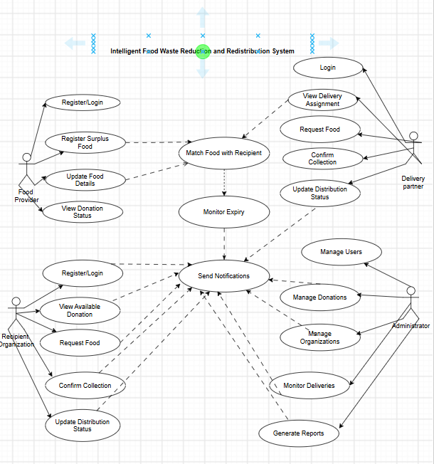
Figure 1.Use Case Diagramof the Food Donation Management System.

4. Object and Class Identification
The major classes identified for the system are:
- User
- FoodProvider
- RecipientOrganization
- DeliveryPartner
- Administrator
- FoodDonation
- FoodItem
- FoodRequirement
- DonationRequest
- Delivery
- Notification
- Location
- Report
Important Attributes
FoodDonation
- donationId
- foodType
- quantity
- preparationTime
- expiryTime
- storageRequirement
- pickupLocation
- status
Delivery
- deliveryId
- pickupLocation
- deliveryLocation
- pickupTime
- deliveryTime
- deliveryStatus
DonationRequest
- requestId
- requestDate
- quantityRequested
- requestStatus

5. Class Diagram
The main relationships between classes are:
- User is the parent class of FoodProvider, RecipientOrganization, DeliveryPartner, and Administrator.
- FoodProvider creates FoodDonation.
- FoodDonation contains FoodItem.
- RecipientOrganization creates DonationRequest.
- DonationRequest is associated with FoodDonation.
- DeliveryPartner handles Delivery.
- FoodDonation is associated with Delivery.
- FoodDonation generates Notification.
- RecipientOrganization has FoodRequirement.
- FoodProvider and RecipientOrganization are associated with Location.
Example Methods
FoodProvider
- addDonation()
- updateDonation()
- viewDonationStatus()
RecipientOrganization
- viewDonations()
- requestDonation()
- confirmCollection()
- updateDistribution()
DeliveryPartner
- acceptDelivery()
- pickupFood()
- deliverFood()
- updateDeliveryStatus()
Administrator
- manageUsers()
- monitorDonations()
- monitorDeliveries()
- generateReport()
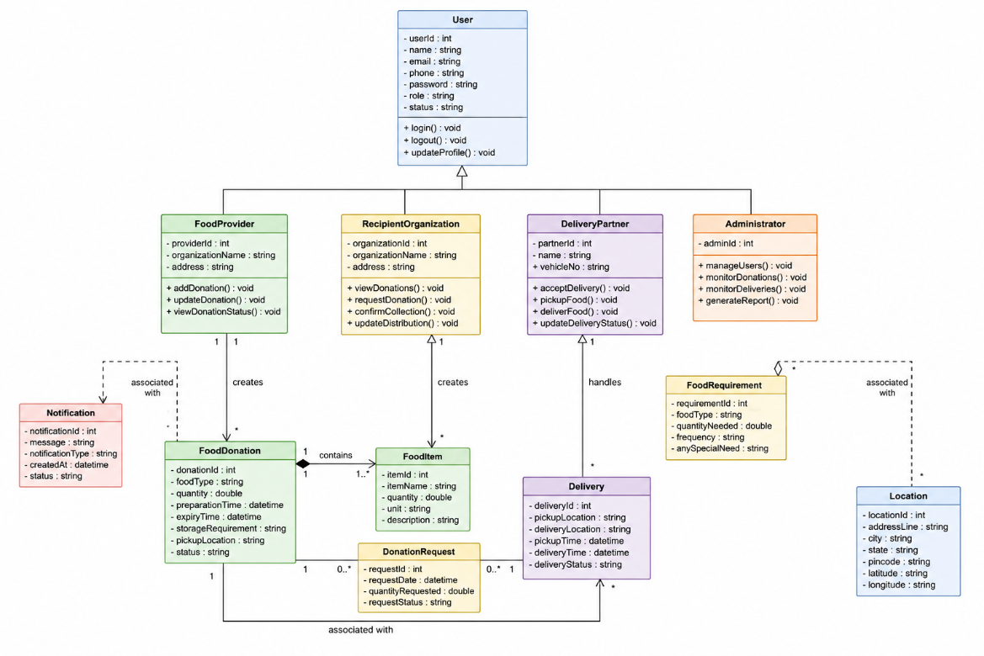
Figure 2.Class Diagram of the Food Donation Management System.

6. Sequence Diagram(s)
Food Donation and Redistribution Sequence
- Food Provider logs into the system.
- Food Provider enters surplus food details.
- Food Provider submits donation.
- System validates the donation.
- System searches for recipient organizations.
- System matches a suitable recipient.
- System sends donation notification.
- Recipient Organization views the donation.
- Recipient Organization submits a request.
- Recipient Organization confirms the request.
- System assigns delivery.
- Delivery Partner confirms pickup.
- Delivery Partner updates delivery status.
- Delivery Partner confirms delivery.
- System notifies the Recipient Organization.
- Recipient Organization updates distribution status.
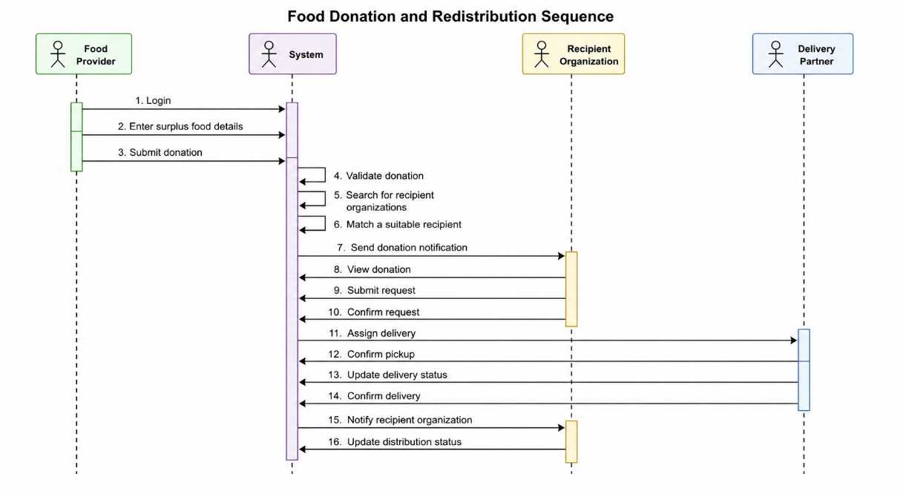 Figure 3. Sequence Diagram of the Food Donation Management System.

7. Activity Diagram
The activity flow of the system is:
Start
↓
Food Provider Login
↓
Enter Surplus Food Details
↓
Validate Information
↓
Register Donation
↓
Check Recipient Requirements
↓
Find Suitable Recipient
↓
Send Notification
↓
Recipient Views Donation
↓
Request Donation
↓
Assign Delivery Partner
↓
Pickup Food
↓
Transport Food
↓
Deliver Food
↓
Recipient Confirms Collection
↓
Update Distribution Status
↓
End
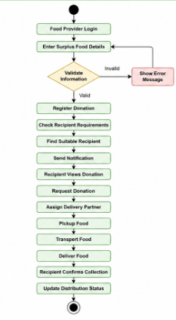
Figure 4.. Activity Diagram of the Food Donation Management System.
8. State Transition Diagram
The Food Donation passes through the following states:
Registered
↓
Available
↓
Matched
↓
Requested
↓
Approved
↓
Pickup Assigned
↓
Picked Up
↓
In Transit
↓
Delivered
↓
Distributed
An alternative transition is:
Available → Expired
The system monitors the expiry period and generates notifications when food is approaching expiry.
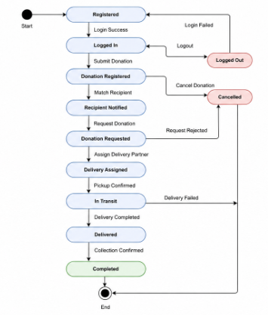
Figure 5. State Transition Diagram of the Food Donation Management System.

9. Package Diagram
The system can be divided into the following packages:
1. User Management
- User
- FoodProvider
- RecipientOrganization
- DeliveryPartner
- Administrator
2. Donation Management
- FoodDonation
- FoodItem
- FoodRequirement
3. Matching Management
- Matching
- MatchingCriteria
4. Request Management
- DonationRequest
5. Delivery Management
- Delivery
- DeliveryAssignment
6. Notification Management
- Notification
- ExpiryNotification
7. Reporting
- Report
- ReportGenerator
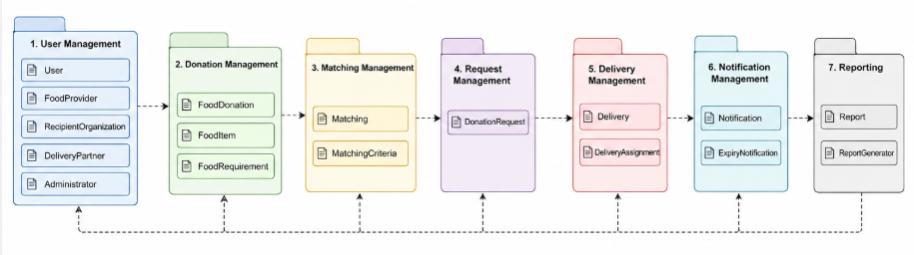
Figure 6.Package Diagram of the Food Donation Management System.

10. Component Diagram
The major components are:
- User Interface
- Authentication Component
- User Management Component
- Donation Management Component
- Food Matching Component
- Request Management Component
- Delivery Management Component
- Notification Component
- Reporting Component
- Database
Component Flow
User Interface → Application Services → Business Components → Database
The Food Matching Component communicates with donation and recipient requirement information. The Notification Component handles expiry-related alerts.
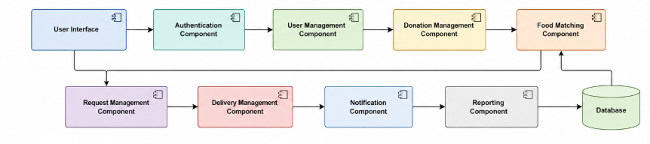
Figure 7.Component Diagram of the Food Donation Management System.

11. Deployment Diagram
Client Devices
- Food Provider Mobile/Web Application
- Recipient Organization Application
- Delivery Partner Application
- Administrator Web Dashboard
↓
Application Server
- Authentication Server
- Donation Management
- Matching Service
- Delivery Management
- Notification Service
- Reporting Service
↓
Database Server
- User Database
- Donation Database
- Organization Database
- Delivery Database
- Transaction Database
The deployment diagram represents communication between client devices, application services, and the database server.
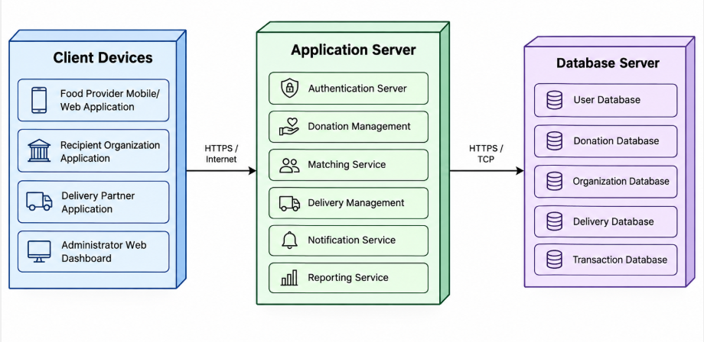
Figure 8. Deployment Diagram of the Food Donation Management System.

12. Object Responsibility Analysis
Object/Class | Main Responsibility
User | Store common user information and authentication details.
FoodProvider | Register and manage surplus food.
RecipientOrganization | Manage food requirements and donation requests.
DeliveryPartner | Manage food pickup and delivery.
Administrator | Monitor and manage the overall system.
FoodDonation | Store surplus food information and donation status.
DonationRequest | Manage requests made by recipient organizations.
Delivery | Track pickup, transportation, and delivery.
Notification | Generate and manage system notifications.
FoodRequirement | Store recipient food requirements.
Report | Provide system monitoring and analytical information.

13. Design Axioms/Principles and Design Pattern Justification
Design Principles
Encapsulation:
Each class keeps its data private and provides methods to access or modify the data.
Abstraction:
Only necessary information is exposed to other components.
High Cohesion:
Each class has a clearly defined responsibility.
Low Coupling:
Classes should have minimum dependency on other classes.
Reusability:
Common functionality should be designed for reuse.
Maintainability:
The system should be divided into independent modules so that future modifications are easier.
Design Patterns
Factory Pattern:
Used to create different types of users such as Food Provider, Recipient Organization, Delivery Partner, and Administrator.
Observer Pattern:
Used for notifications. When a donation approaches expiry or its status changes, relevant users can automatically receive notifications.
Strategy Pattern:
Used for different food-matching strategies based on location, quantity, urgency, or food requirements.

14. Assumptions and Constraints
Assumptions
- Users have valid registration details.
- Food providers provide accurate food and expiry information.
- Recipient organizations provide accurate food requirements.
- Delivery partners have access to required delivery information.
- Users have access to the internet.
- Food providers and recipient organizations follow appropriate food safety practices.
- The system has access to accurate location information.
Constraints
- Food must be redistributed before its expiry period.
- Matching must consider quantity, location, urgency, and availability.
- User access must depend on assigned roles.
- Donation and delivery information must remain consistent.
- Transactions must be recorded accurately.
- UML diagrams must be mutually consistent.

15. Requirement-to-Use Case/Class Traceability
Requirement | Use Case | Related Classes
Register surplus food | Register Surplus Food | FoodProvider, FoodDonation
Store food details | Manage Donation | FoodDonation, FoodItem
Find suitable recipient | Match Donation | FoodDonation, FoodRequirement, RecipientOrganization
Request donation | Request Food | RecipientOrganization, DonationRequest
Assign delivery | Manage Delivery | DeliveryPartner, Delivery
Track delivery | Update Delivery Status | Delivery, DeliveryPartner
Monitor expiry | Monitor Expiry | FoodDonation, Notification
Notify users | Send Notification | Notification, User
Manage users | Manage Users | User, Administrator
Generate reports | Generate Reports | Report, Administrator

16. Implementation/Prototype and Results
A prototype of the IFWRRS can be developed as a web or mobile-based application.
Prototype Modules
- User Registration and Login
- Food Provider Dashboard
- Surplus Food Registration
- Recipient Organization Dashboard
- Food Matching Module
- Donation Request Module
- Delivery Management
- Expiry Notification
- Administrator Dashboard
- Reports
Expected Results
The prototype should demonstrate that:
- Food providers can register surplus food successfully.
- Recipient organizations can view and request available food.
- The system can identify suitable recipients.
- Delivery partners can receive and update delivery assignments.
- Expiry notifications can be generated.
- Administrators can monitor system activities.
- Food donation and delivery status can be tracked.

17. Reflection on Design Decisions and Learning Outcomes
The development of the IFWRRS model helped in understanding how Object-Oriented Analysis and Design concepts can be applied to a real-world problem. The system was analysed by identifying actors, objects, classes, attributes, and methods.
The development of different UML diagrams helped in understanding the structural and behavioural aspects of the system. The Use Case Diagram represents user interactions, while the Class Diagram represents the structure of the system. Sequence, Activity, and State Transition Diagrams describe system behaviour. Package, Component, and Deployment Diagrams represent the architectural structure.
The use of principles such as encapsulation, abstraction, high cohesion, and low coupling improves the maintainability and scalability of the proposed system. Design patterns such as Factory, Observer, and Strategy can further improve reusability and flexibility.
The project is also relevant to SDG 2 – Zero Hunger, SDG 11 – Sustainable Cities and Communities, SDG 12 – Responsible Consumption and Production, and SDG 13 – Climate Action.
Overall, the assignment provides practical understanding of converting a real-world problem into an object-oriented software model using UML and applying appropriate design principles to produce a feasible, maintainable, and scalable system.

